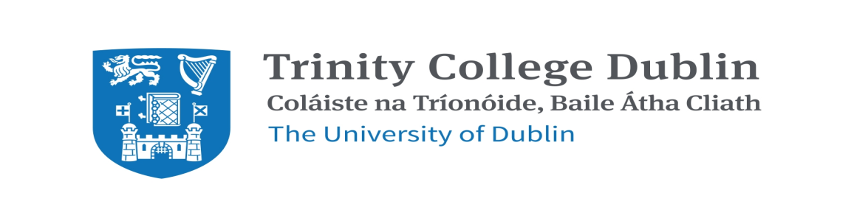
Interested in a Job in Hospital Pharmacy?
Do You Want to Enhance your Future Career Prospects by Completing an MSc While You Work?

Two job vacancies have arisen in two Dublin Area Teaching Hospitals for places on the two year, part-time hybrid M.Sc. in Hospital Pharmacy with the School of Pharmacy and Pharmaceutical Sciences, Trinity College Dublin, commencing in January 2024.

Informal enquiries to Niamh McMahon, Course Director, nmcmahon@tcd.ie
or see MSc Course webpage:http://www.pharmacy.tcd.ie/postgraduate/msc_hospital.php
Closing Date: 31st October 2023.

